**UNIVERSITY OF MANAGEMENT & TECHNOLOGY LAHORE CAMPUS.**

Project Title

Project Id From the portal

**Group Members**

|  |  |  |
| --- | --- | --- |
| **Name** | **ID** | **Email** |
| **Muhammad Arshad** | **F2021266088** | **F2021266088@umt.edu.pk** |
| **Null** |  |  |
| **null** |  |  |

**Abstract**

The time a heard that we are going to have an OOP project, I got very nervous of what topic I should chose, should I do it alone, grouped or should I do it all, then one day at the weekend I needed a car, so like every other person who don’t own a car I went to car rental office, I was surprised to find that it was closed, Of course you cannot blame the employee after all he is a human who needs rest like others.

Then out of nowhere I said to myself I wish they make a machine that rents cars to people, I thought for a moment and said why am I studying CS if I can’t develop a prototype of this, I liked the idea and started gathering some ideas.

After a long search I found out all you need is an ATM shaped machine, a parking lot and a power plug to run the machine, I decided my OOP project subject, **A SELF CAR RENTAL SYSTEM.**

The program I developed is very simple actually, 2 persons can access the machine, a user (customer) and an admin(owner), the user can take the cars for rent, the admin can add, remove cars and change prices, very simple and very useful, think about it; whenever you want a rented car you just go there put your data and money, take the car and that’s a lot of time and effort saved of finding an office talking to the manager there and everything.

There are some drawbacks in it, like there should be security, cars can get stolen or the machine itself may get stolen, a power cut can stop the action and the most important it is a piece of code running millions of rupees, It can be hacked,

Regardless, I delivered my best in this project and I hope it gets some attention

**Introduction:**

**A car rental system that may replace a manager who sits on a desk 9 hours a day, and make it easy for customers to rent a car anytime.**

**Functionalities:**

* **Cars can be added or deleted by the Admin**
* **Prices are not fixed.**
* **The customer data is saved in txt file outside the program.**
* **Cars cannot be repeated**

**Explain your project functionalities**

1. **Admin can add a new car to the collection for there is room for 100 car in the code and also can delete defected cars.**
2. **Raise or lowering in price can easily take place by the admin for there is function for that.**
3. **A ofstream type is used to save the data eneterd by the user in a folder outside the program to be accessed again later.**
4. **Once a car is rented it cannot be rented again, it just disappears from the list and the admin has to add it manually.**

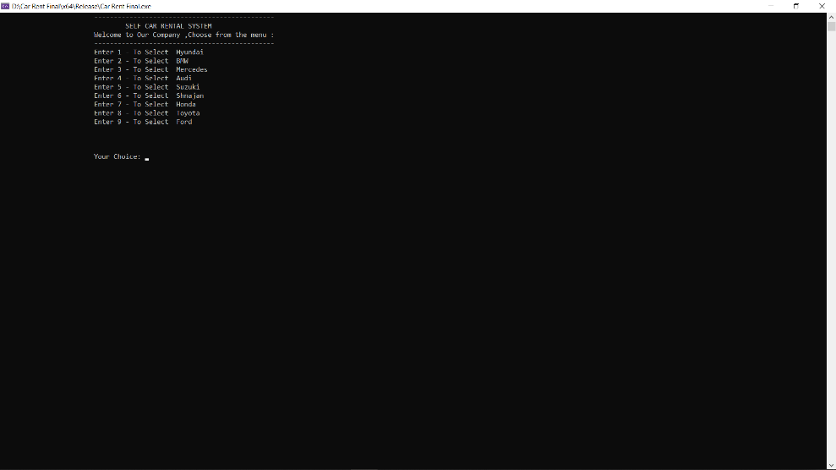**Interfaces/screenshots of running state:**

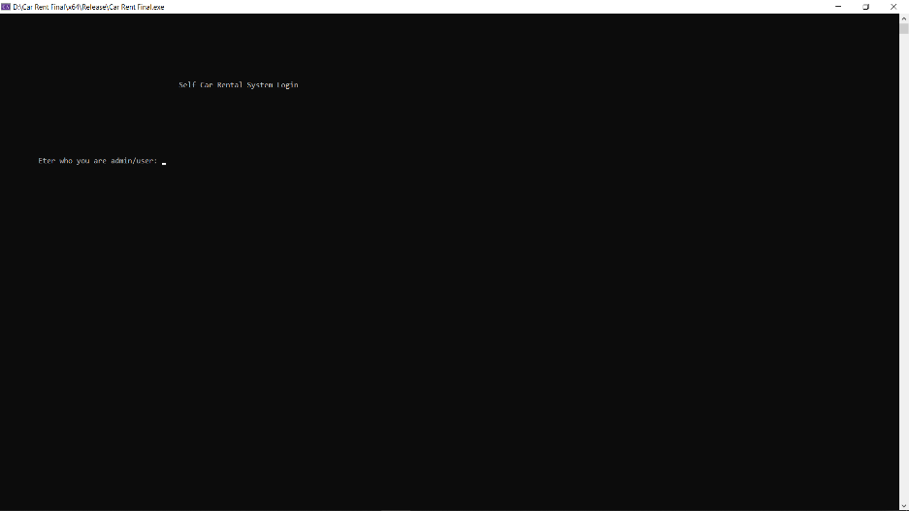**Attached running screenshots**

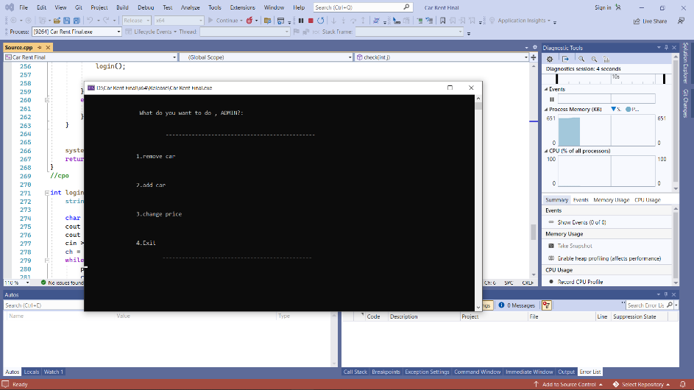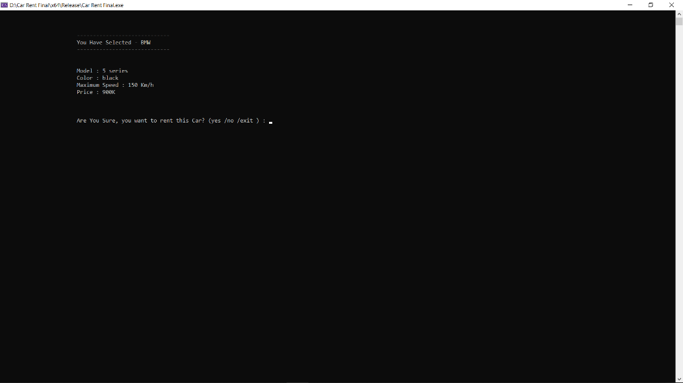

**Conclusion:**

In conclusion The project is still missing a lot and it can be improved a lot, and I hope in the future with some seniors help and self-effort I can make this project have a meaning to it and it will get attention.